Lampiran 1

**HASIL UJI PENDAHULUAN DATA PRIMER PENGUJIAN LABORATORIUM**

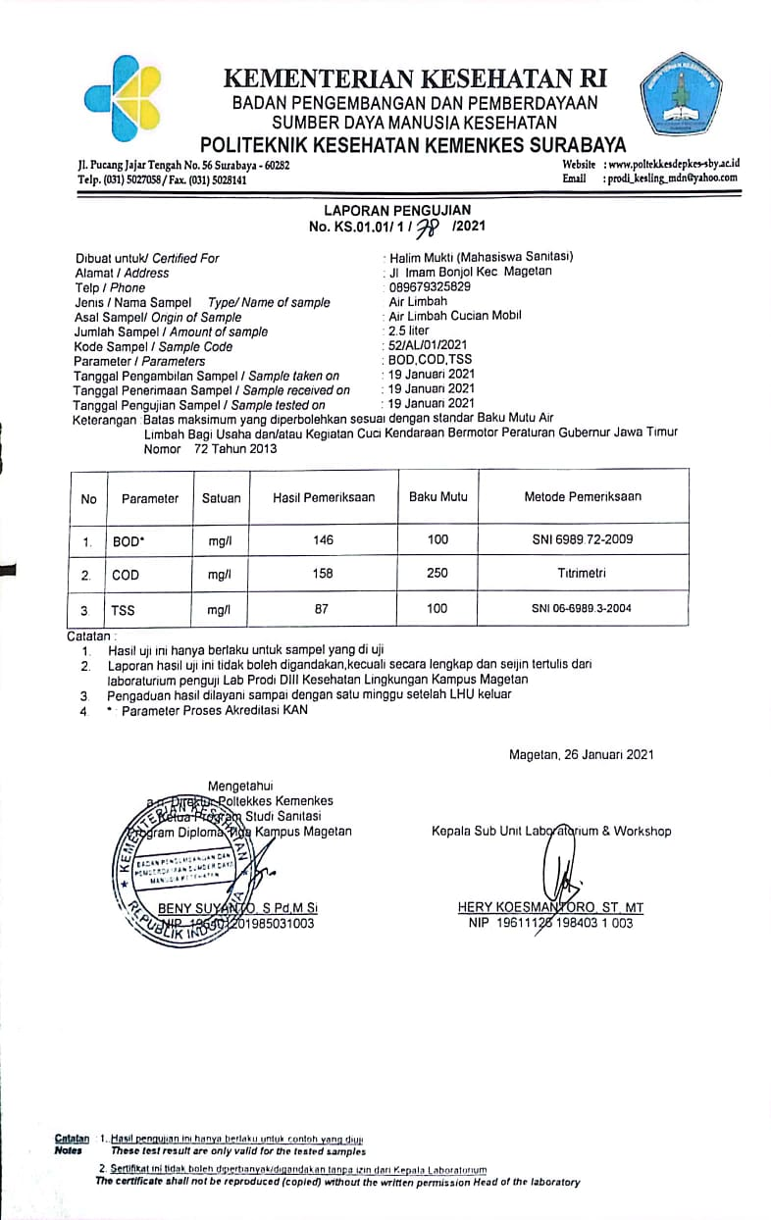

Lampiran 2

|  |  |  |
| --- | --- | --- |
|  |  | POLTEKKES KEMENKES SURABAYA  PRODI D-III SANITASI MAGETAN |
| Keterangan :   1. Peta Lokasi Penelitian 2. Titik merah adalah lokasi penelitian   Jl. Imam Bonjol, Kecamatan Magetan, Kabupaten Magetan | |
| Di buat oleh :  Halim Mukti Alwi  P27833218028  Tahun 2021 | |

Lampiran 3

**ANGGARAN BIAYA PENELITIAN**

|  |  |  |  |  |
| --- | --- | --- | --- | --- |
| **No** | **Nama Barang** | **Volume** | **Harga** | **Total** |
| 1 | Bak | 2 | @Rp. 45.000,00 | Rp. 90.000,00 |
| 2 | Bak Kontainer | 2 | @Rp. 100.000,00 | Rp. 100.000,00 |
| 3 | Besi | 5 | @Rp. 35.000,00 | Rp. 175.000,00 |
| 4 | Aerator | 1 | @Rp. 50.000,00 | Rp. 50.000,00 |
| 5 | Pipa | 1m | @Rp. 15.000,00 | Rp. 15.000,00 |
| 6 | Stop Kran | 4 | @Rp. 8.500,00 | Rp. 34.000,00 |
| 7 | Tinta Print | 2 | @Rp. 85.000,00 | Rp. 170.000,00 |
| 8 | Kertas | 4rim | @Rp. 50.000,00 | Rp. 200.000,00 |
| 9 | Transportasi | 5 | @Rp. 20.000,00 | Rp. 100.000,00 |
| 10 | Pemeriksaan Sampel | 24 | @Rp. 35.000,00 | Rp. 840.000,00 |
| **Total Keseluruhan** | | | | Rp. 1.874.000,00 |

Lampiran 4

**DATA HASIL KADAR BOD SEBELUM PERLAKUAN**

|  |  |  |  |
| --- | --- | --- | --- |
| **Sampel** | **Waktu** | **Replikasi** | **Kadar BOD (mg/L)** |
| **Sebelum Perlakuan** |
| 1 | 60 menit | 1 | 127 |
| 2 | 2 | 127 |
| 3 | 3 | 127 |
| 4 | 4 | 127 |
| 5 | 5 | 127 |
| 6 | 6 | 127 |
| 7 | 120 menit | 1 | 127 |
| 8 | 2 | 127 |
| 9 | 3 | 127 |
| 10 | 4 | 127 |
| 11 | 5 | 127 |
| 12 | 6 | 127 |
| 13 | 180 menit | 1 | 127 |
| 14 | 2 | 127 |
| 15 | 3 | 127 |
| 16 | 4 | 127 |
| 17 | 5 | 127 |
| 18 | 6 | 127 |
| 19 | 240 menit | 1 | 127 |
| 20 | 2 | 127 |
| 21 | 3 | 127 |
| 22 | 4 | 127 |
| 23 | 5 | 127 |
| 24 | 6 | 127 |
| **Jumlah** | | | 3048 |
| **Rata-rata** | | | 127 |

Lampiran 5

**DATA HASIL KADAR BOD SESUDAH PERLAKUAN**

|  |  |  |  |  |
| --- | --- | --- | --- | --- |
| **Sampel** | **Waktu** | **Replikasi** | **Kadar BOD (mg/L)** | |
| **Sebelum** | **Sesudah** |
| 1 | 60 menit | 1 | 127 | 107 |
| 2 | 2 | 127 | 98 |
| 3 | 3 | 127 | 114 |
| 4 | 4 | 127 | 87 |
| 5 | 5 | 127 | 95 |
| 6 | 6 | 127 | 100 |
| 7 | 120 menit | 1 | 127 | 85 |
| 8 | 2 | 127 | 104 |
| 9 | 3 | 127 | 77 |
| 10 | 4 | 127 | 89 |
| 11 | 5 | 127 | 66 |
| 12 | 6 | 127 | 78 |
| 13 | 180 menit | 1 | 127 | 59 |
| 14 | 2 | 127 | 64 |
| 15 | 3 | 127 | 58 |
| 16 | 4 | 127 | 86 |
| 17 | 5 | 127 | 75 |
| 18 | 6 | 127 | 62 |
| 19 | 240 menit | 1 | 127 | 46 |
| 20 | 2 | 127 | 52 |
| 21 | 3 | 127 | 48 |
| 22 | 4 | 127 | 39 |
| 23 | 5 | 127 | 40 |
| 24 | 6 | 127 | 37 |
| **Jumlah** | | | | 1766 |
| **Rata-rata** | | | | 73,58 |

Lampiran 6

**DATA HASIL EFEKTIVITAS PENURUNAN KADAR BOD**

|  |  |  |  |  |  |  |
| --- | --- | --- | --- | --- | --- | --- |
| Sampel | Waktu | Replikasi | Kadar BOD (mg/L) | | Penurunan (mg/L) | Efektivitas (%) |
| Sebelum | Sesudah |
| 1 | 60 menit | 1 | 127 | 107 | 20 | 15,74 % |
| 2 | 2 | 127 | 98 | 29 | 22,83% |
| 3 | 3 | 127 | 114 | 13 | 10,23 % |
| 4 | 4 | 127 | 87 | 40 | 31,49 % |
| 5 | 5 | 127 | 95 | 32 | 25,19 % |
| 6 | 6 | 127 | 100 | 27 | 21,25 % |
| 7 | 120 menit | 1 | 127 | 85 | 42 | 33,07 % |
| 8 | 2 | 127 | 104 | 23 | 18,11 % |
| 9 | 3 | 127 | 77 | 50 | 39,37 % |
| 10 | 4 | 127 | 89 | 38 | 29,92 % |
| 11 | 5 | 127 | 66 | 61 | 48,03 % |
| 12 | 6 | 127 | 78 | 49 | 38,58 % |
| 13 | 180 menit | 1 | 127 | 59 | 68 | 53,54 % |
| 14 | 2 | 127 | 64 | 63 | 49,60 % |
| 15 | 3 | 127 | 58 | 69 | 54,33 % |
| 16 | 4 | 127 | 86 | 41 | 32,28 % |
| 17 | 5 | 127 | 75 | 52 | 40,94 % |
| 18 | 6 | 127 | 62 | 65 | 51,18 % |
| 19 | 240 menit | 1 | 127 | 46 | 81 | 63,77 % |
| 20 | 2 | 127 | 52 | 71 | 59,05 % |
| 21 | 3 | 127 | 48 | 79 | 62,20 % |
| 22 | 4 | 127 | 39 | 88 | 69,29 % |
| 23 | 5 | 127 | 40 | 87 | 68,50 % |
| 24 | 6 | 127 | 37 | 90 | 70,86 % |
| **Jumlah** | | | 3048 | 1766 | 1282 | 1009,35 % |
| **Rata-rata** | | | 127 | 73,58 | 53,41 | 42,05 % |

Lampiran 7

**ANOVA**

|  | Sum of Squares | df | Mean Square | F | Sig. |
| --- | --- | --- | --- | --- | --- |
| Between Groups | 10395.500 | 3 | 3465.167 | 33.801 | .000 |
| Within Groups | 2050.333 | 20 | 102.517 |  |  |
| Total | 12445.833 | 23 |  |  |  |

**Multiple Comparisons**

Nilai BOD

LSD

| (I) waktu | (J) waktu | Mean Difference (I-J) | Std. Error | Sig. | 99% Confidence Interval | |
| --- | --- | --- | --- | --- | --- | --- |
| Lower Bound | Upper Bound |
| 60menit | 120menit | 17.000* | 5.846 | .009 | .37 | 33.63 |
| 180menit | 32.833* | 5.846 | .000 | 16.20 | 49.47 |
| 240menit | 56.500* | 5.846 | .000 | 39.87 | 73.13 |
| 120menit | 60menit | -17.000* | 5.846 | .009 | -33.63 | -.37 |
| 180menit | 15.833* | 5.846 | .014 | -.80 | 32.47 |
| 240menit | 39.500* | 5.846 | .000 | 22.87 | 56.13 |
| 180menit | 60menit | -32.833* | 5.846 | .000 | -49.47 | -16.20 |
| 120menit | -15.833* | 5.846 | .014 | -32.47 | .80 |
| 240menit | 23.667 | 5.846 | .001 | 7.03 | 40.30 |
| 240menit | 60menit | -56.500* | 5.846 | .000 | -73.13 | -39.87 |
| 120menit | -39.500* | 5.846 | .000 | -56.13 | -22.87 |
| 180menit | -23.667 | 5.846 | .001 | -40.30 | -7.03 |
| *. The mean difference is significant at the 0.01 level. | | | | |  |  |

**MEANS**

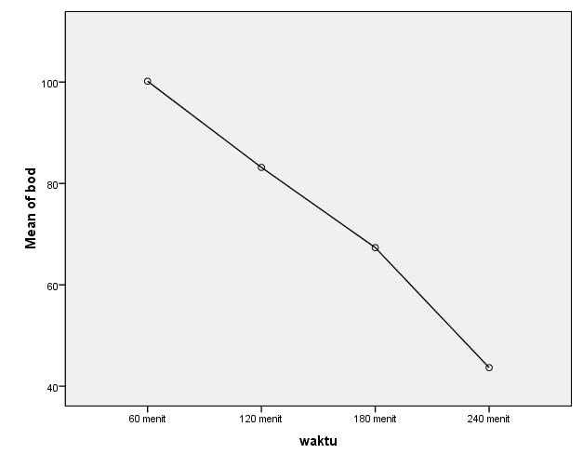

Lampiran 8

**HASIL DATA PRIMER PENGUJIAN LABORATORIUM**

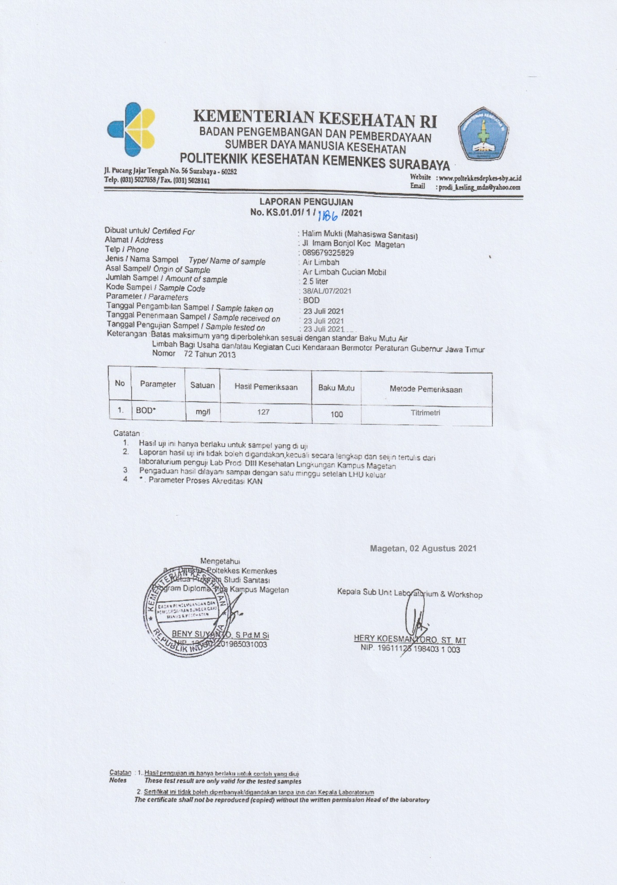

**HASIL DATA PRIMER PENGUJIAN LABORATORIUM**

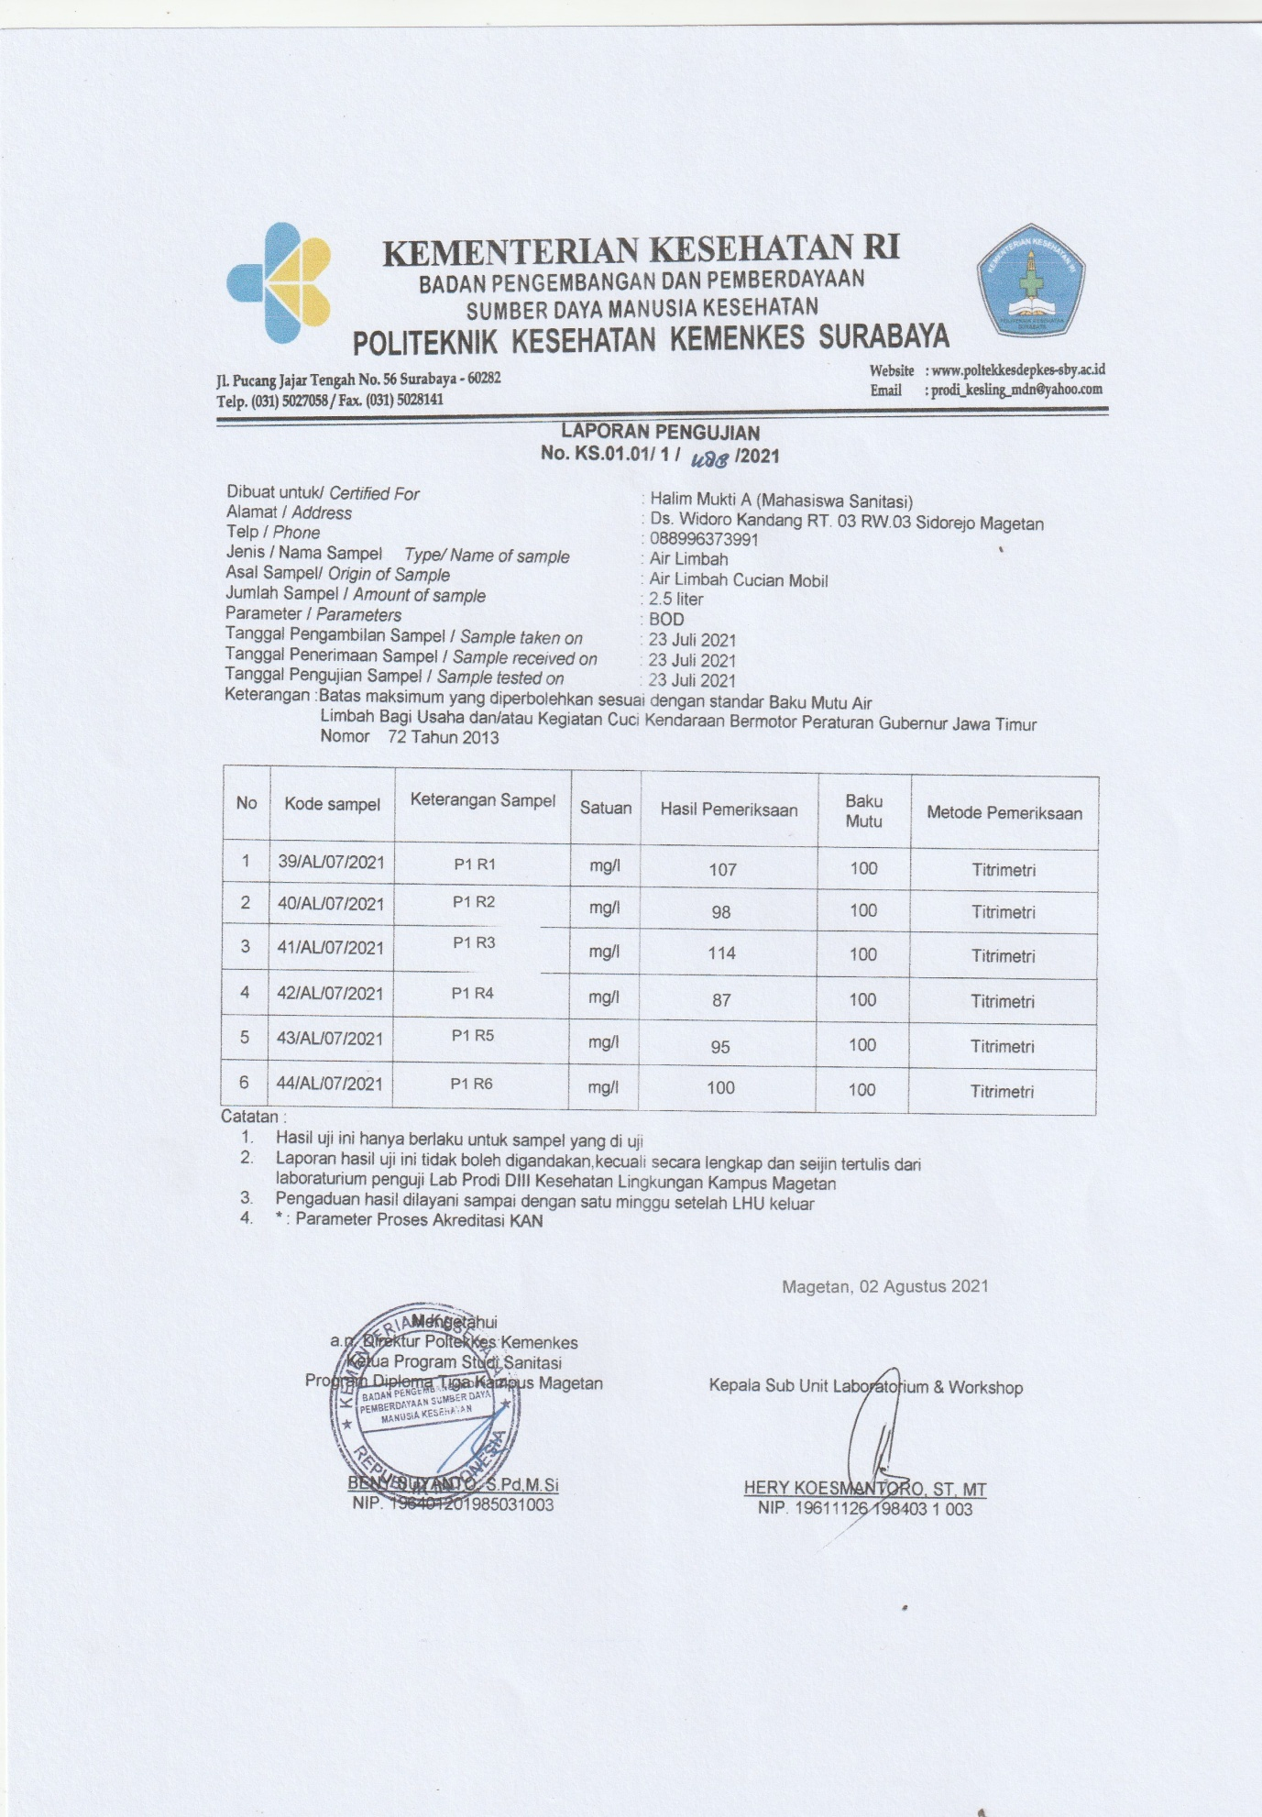

**HASIL DATA PRIMER PENGUJIAN LABORATORIUM**

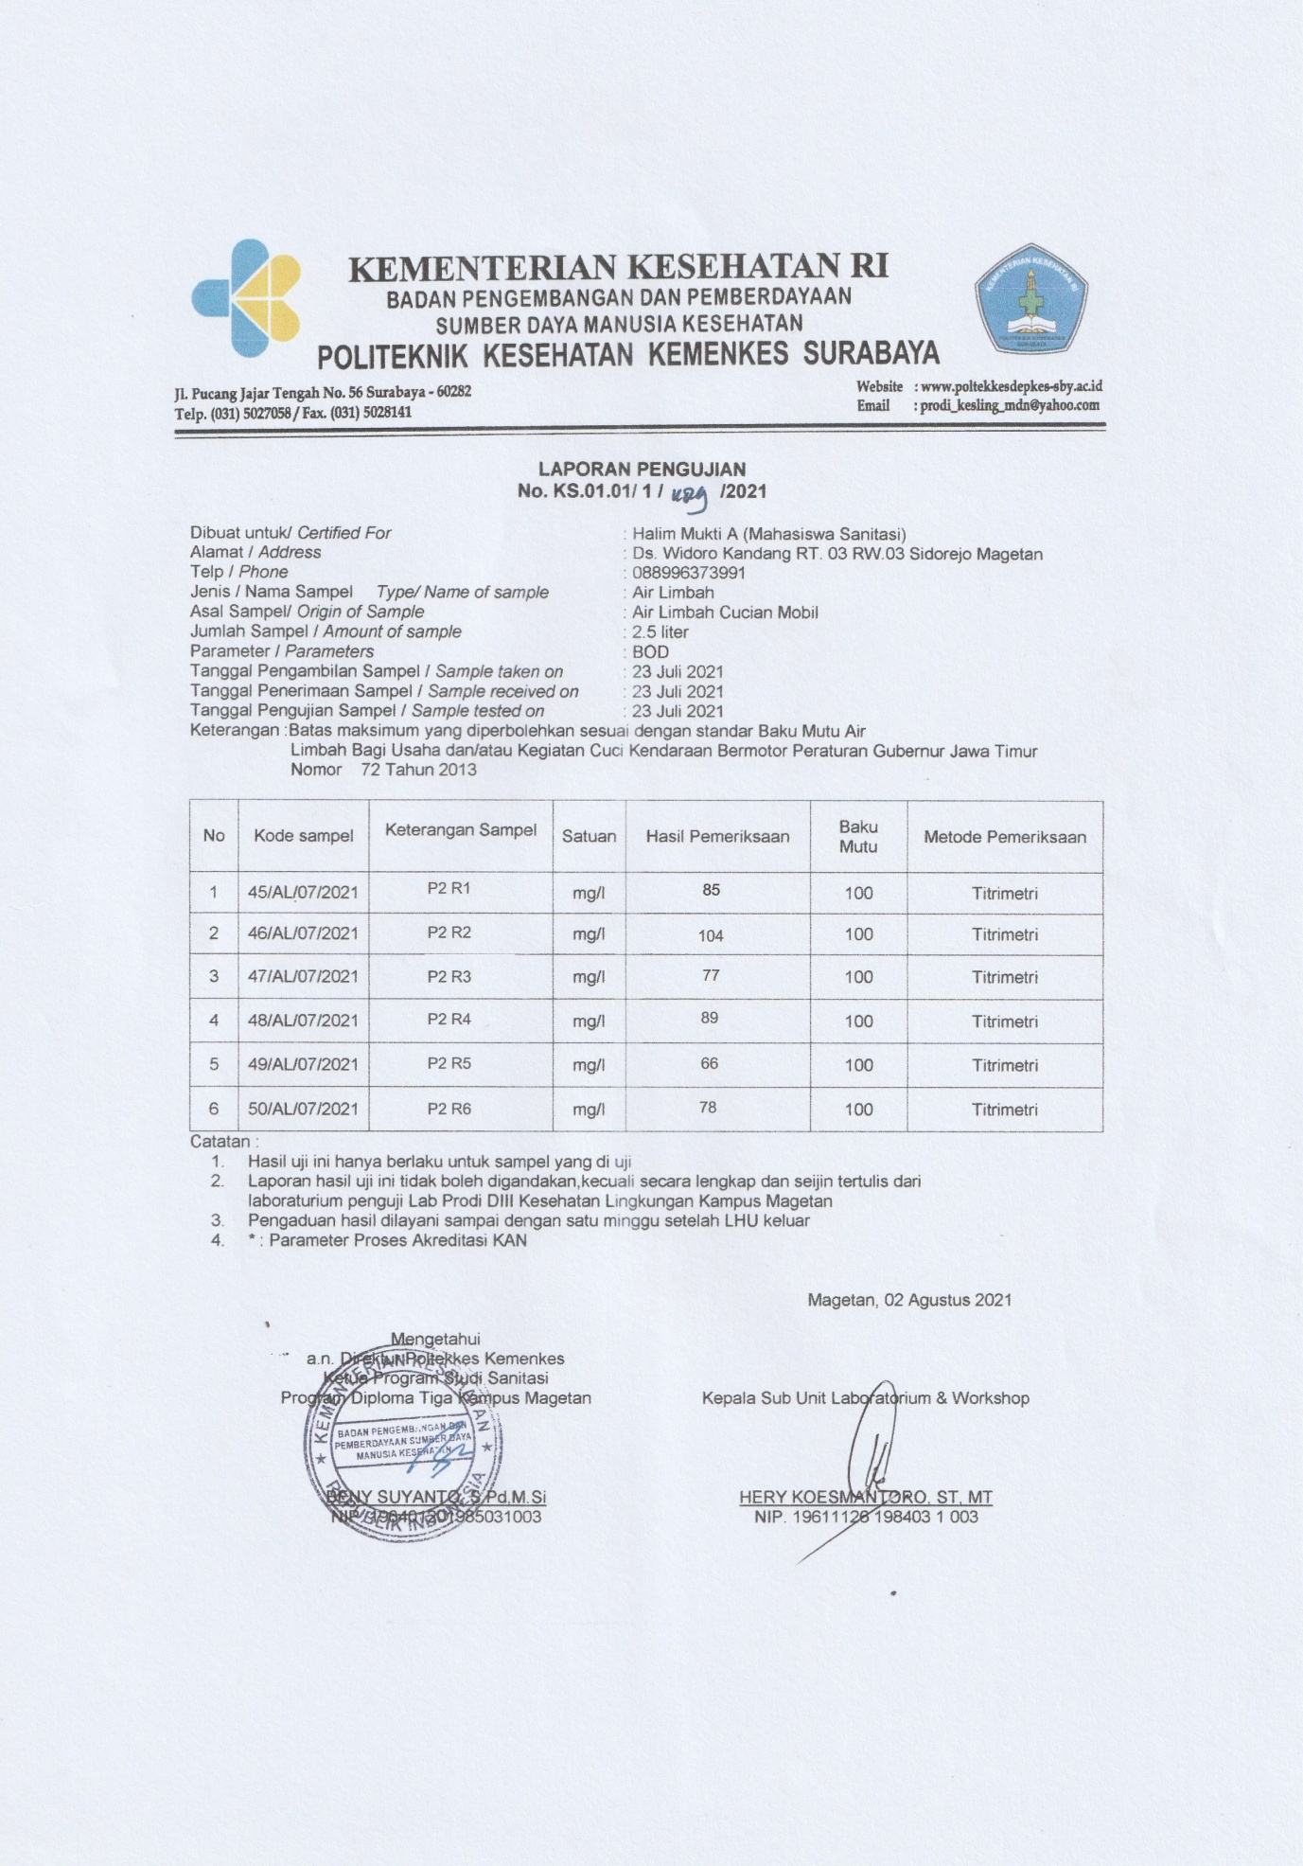

**HASIL DATA PRIMER PENGUJIAN LABORATORIUM**

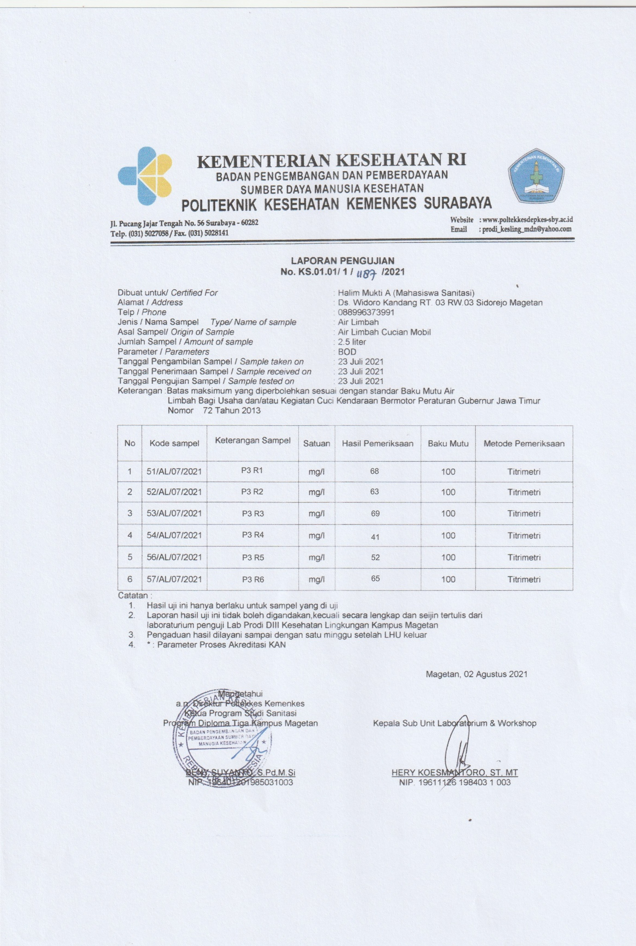

**HASIL DATA PRIMER PENGUJIAN LABORATORIUM**

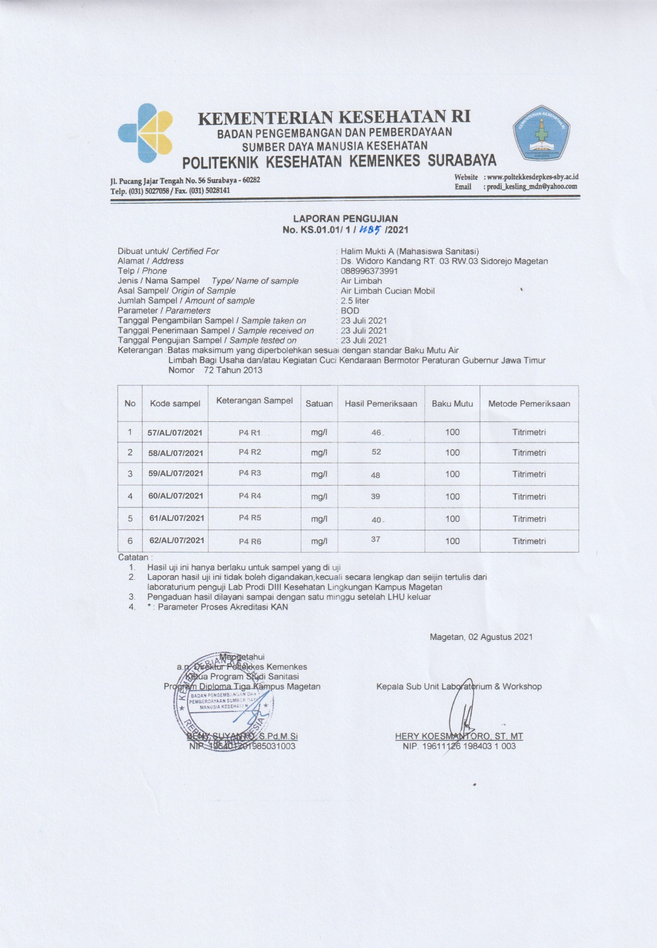

Lampiran 9

**Hasil Dokumentasi Pada Saat Penelitian**

|  |  |  |  |
| --- | --- | --- | --- |
| **No** | **Keterangan** | **No** | **Keterangan** |
| 1 | Proses pencucian mobil | 2 | Pembuatan Kerangka |
| 3 | Pembuatan Kerangka | 4 | Bak yang di gunakan |

**Hasil Dokumentasi Pada Saat Penelitian**

|  |  |  |  |
| --- | --- | --- | --- |
| **No** | **Keterangan** | **No** | **Keterangan** |
| 5 | Aerator untuk proses aerasi | 6  Pengukuran tinggi pipa filtrasi |  |
| 7 | Ijuk sebagai media filtrasi | 8  Genteng sebagai media filtrasi |  |

**Hasil Dokumentasi Pada Saat Penelitian**

|  |  |  |  |
| --- | --- | --- | --- |
| **No** | **Keterangan** | **No** | **Keterangan** |
| 5 | Kerikil sebagai media filtrasi | 6  Pengukuran ketebalan media |  |
| 7 | Alat yang sudah jadi | 8  Proses penelitian |  |

**Hasil Dokumentasi Pada Saat Penelitian**

|  |  |  |  |
| --- | --- | --- | --- |
| **No** | **Keterangan** | **No** | **Keterangan** |
| 9 | Proses Penelitian | 10  Proses Penelitian |  |
| 11 | Proses Penelitian | 12  Proses penelitian |  |

**Hasil Dokumentasi Pada Saat Penelitian**

|  |  |  |  |
| --- | --- | --- | --- |
| **No** | **Keterangan** | **No** | **Keterangan** |
| 13 | Proses Penelitian | 14  Penyimpanan sampel dikulkas |  |

Lampiran 10

**HASIL UJI TURNITIN**

