DAFTAR LAMPIRAN

Lampiran 1
Kuesinoer Penelitian

KUESINOER PENINGKATAN PENGETAHUAN SANTRI TENTANG PENYAKIT SKABIES MENGGUNAKAN MEDIA VIDEO DI PONDOK PESANTREN MATSARATUL HUDA KABUPATEN PAMEKASAN TAHUN 2025

- Petunjuk Pengisian
Isi kolom pada lembar kuesioner pengetahuan pencegahan penyakit scabies (gudikan/kudis) sesuai dengan kondisi yang anda alami. Berilah tanda (√) pada yang akan dipilih.
Nama :
Umur :
Jenis Kelamin :
Pendidikan :

No | Pertanyaan | Benar | Salah
1. | Scabies adalah penyakit kulit yang disebabkan oleh tungau sarcoptes scabiei
2. | Scabies dapat ditularkan oleh kutu sarcoptes scabiei betina yang telah dibuahi
3. | Scabies ditularkan melalui pemakaian pakaian, handuk atau alat sholat yang dipakai secara bergantian
4. | Kontak fisik berjabat tangan dengan penderita dapat menularkan penyakit scabies
5. | Gejala yang ditimbulkan oleh penyakit scabies adalah rasa gatal hebat terutama pada malam hari
6. | Kemerahan kulit pada penderita scabies biasanya ditemukan dilipatan kulit tipis hangat dan lembab seperti disela jari tangan, bawah ketiak, punggung, pergelangan tangan dan selangkangan.
7. | Penularan tidak langsung penyakit scabies adalah melalui perlengkapan tidur, pakaian, atau handuk, sprei, bantal, dll
8. | Penyakit scabies ini sangat mudah menular dan menyebar di lingkungan seperti perkampungan padat penduduk, asrama (pondok pesantren).
9. | Scabies tidak ditularkan melalui pemakaian handuk secara bergantian
10. | Orang yang dapat menjaga kebersihan tubuhnya dapat terkena scabies
11. | Scabies dapat Dicegah dengan mandi menggunakan sabun secara teratur
12. | Kutu penyebab scabies tidak dapat hidup dilingkungan yang lembab
13. | Kamar yang berventilasi tidak mempermudah perkembangbiakan kutu penyebab scabies
14. | penyakit scabies tidak ada hubungannya dengan kebersihan lingkungan
15. | Pakaian atau handuk yang tidak dijemur sampai kering bukan menjadi tempat berkembangbiaknya kutu sarcoptes scabiei

Keterangan :
Benar : 2
Salah : 1

Lampiran 2

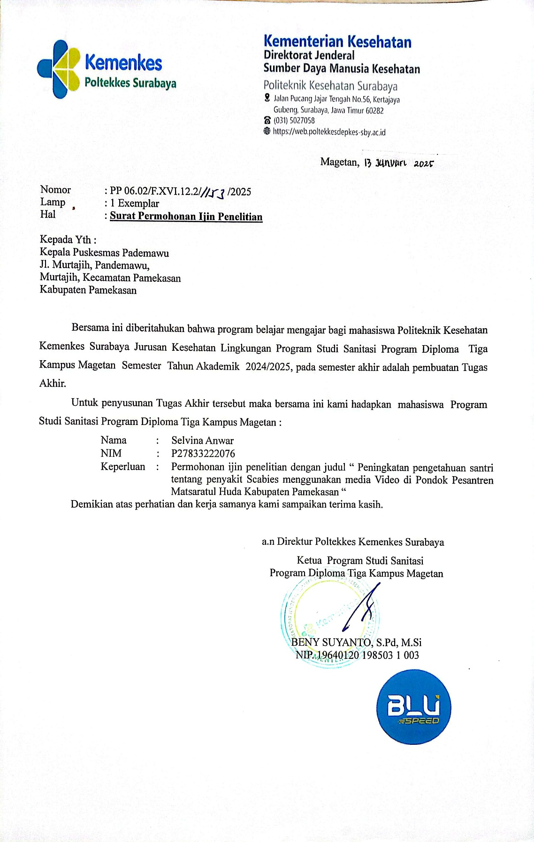
Surat Pengambilan Data Penyakit Skabies di Puskesmas
Lampiran 2

Surat Ijin Penelitian di Badan Kesatuan Bangsa dan Politik
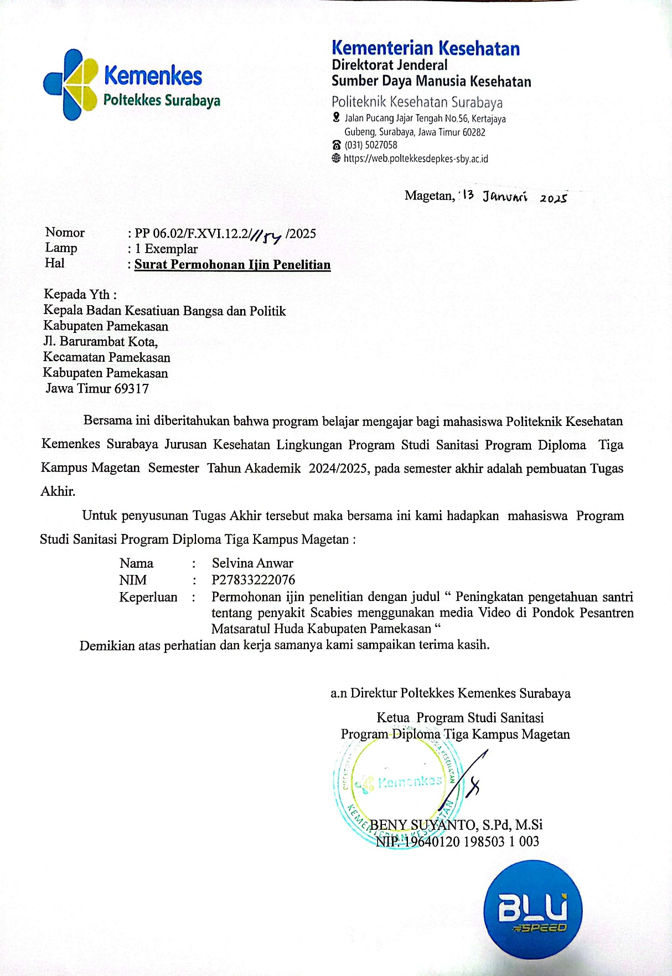
Lampiran3

Surat Ijin Penelitian di Pondok Pesantren Matsaratul Huda
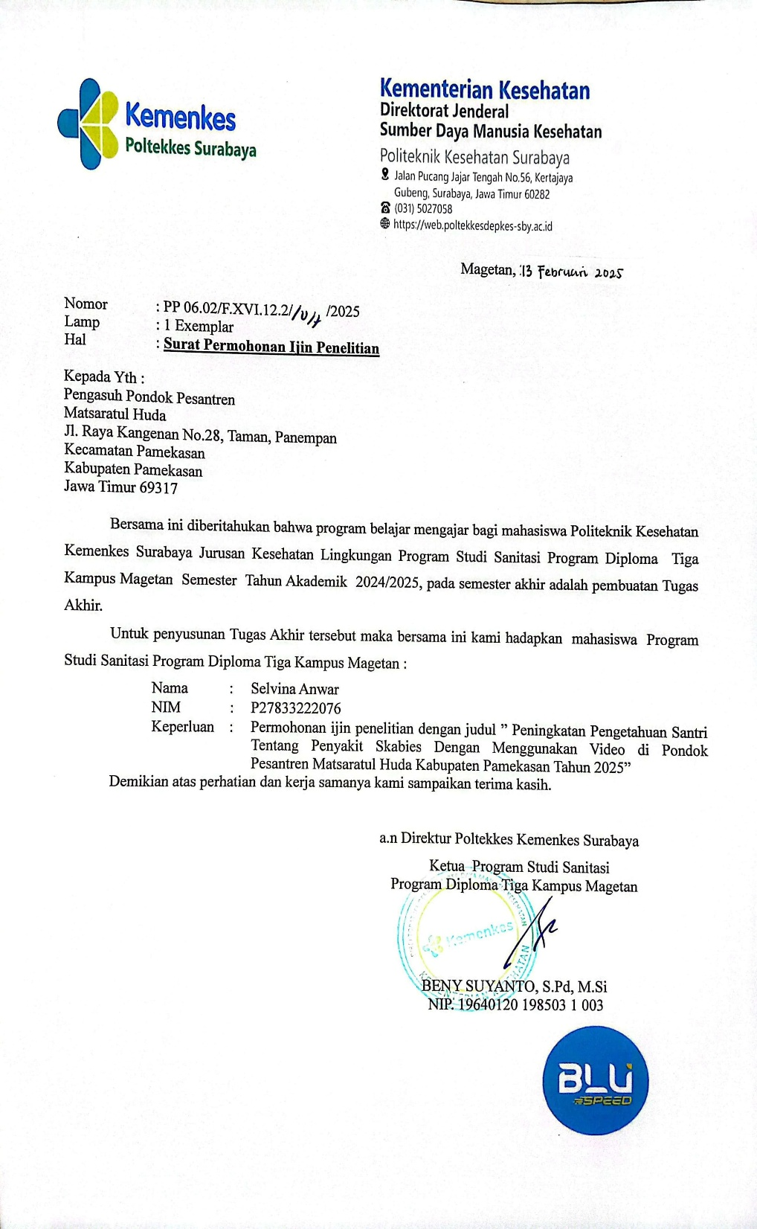

Lampiran 4
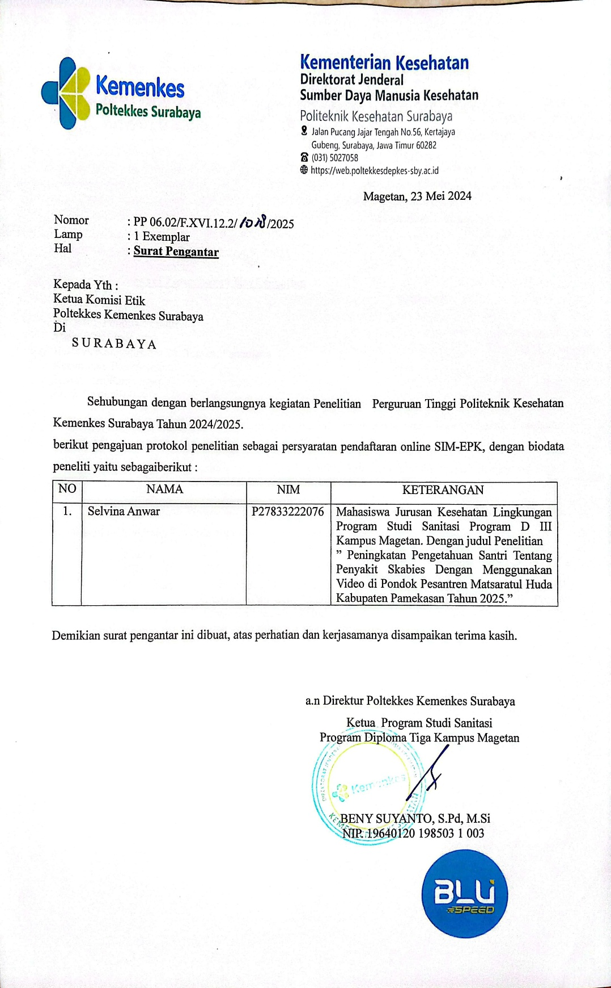
Surat Pengantar Komisi Etik

Lampiran 5
Keterangan Layak Etik
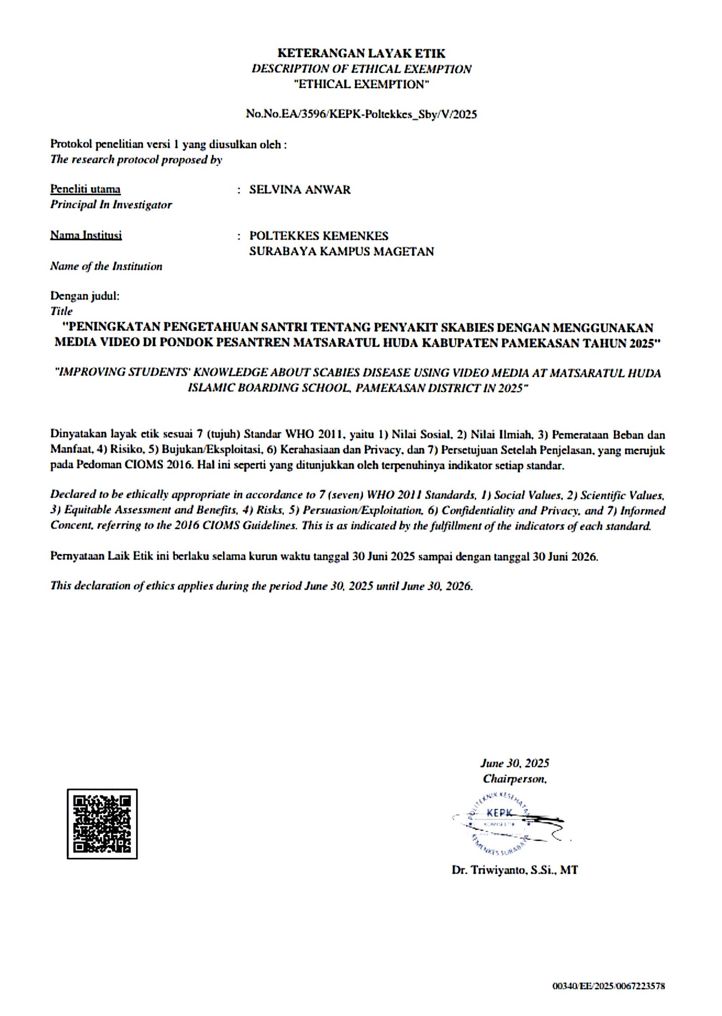

Lampiran 5
Hasil Kuesioner Pengetahuan Santri di Pondok Pesantren Matsaratul Huda Kabupaten Pamekasan Sebelum Diberikan Promosi Kesehatan Tentang Penyakit Skabies

Res | Soal |  |  |  |  |  |  |  |  |  |  |  |  |  |  | Jumlah | Kat
Res | 1 | 2 | 3 | 4 | 5 | 6 | 7 | 8 | 9 | 10 | 11 | 12 | 13 | 14 | 15 | Jumlah
P | 1 | 1 | 1 | 1 | 1 | 1 | 1 | 2 | 1 | 1 | 1 | 1 | 1 | 1 | 1 | 16 | 1
P | 1 | 1 | 1 | 1 | 1 | 1 | 1 | 1 | 1 | 1 | 1 | 1 | 1 | 1 | 1 | 15 | 1
P | 1 | 1 | 1 | 1 | 1 | 1 | 1 | 1 | 1 | 1 | 1 | 1 | 1 | 1 | 1 | 15 | 1
P | 1 | 1 | 1 | 1 | 1 | 2 | 1 | 1 | 1 | 2 | 1 | 1 | 1 | 1 | 1 | 17 | 1
P | 1 | 1 | 1 | 1 | 1 | 2 | 1 | 1 | 1 | 1 | 1 | 1 | 1 | 1 | 1 | 16 | 1
P | 1 | 1 | 1 | 1 | 1 | 1 | 2 | 2 | 2 | 1 | 1 | 1 | 1 | 1 | 1 | 18 |  | 2
P | 1 | 1 | 1 | 1 | 1 | 1 | 1 | 1 | 2 | 1 | 1 | 1 | 1 | 1 | 1 | 16 | 1
P | 1 | 1 | 1 | 1 | 1 | 2 | 1 | 1 | 1 | 1 | 1 | 1 | 1 | 1 | 1 | 16 | 1
P | 1 | 1 | 1 | 1 | 2 | 1 | 1 | 1 | 1 | 1 | 2 | 1 | 1 | 1 | 1 | 17 | 1
P | 1 | 1 | 1 | 1 | 1 | 1 | 2 | 1 | 1 | 1 | 2 | 2 | 2 | 2 | 1 | 20 | 1
P | 1 | 1 | 1 | 1 | 2 | 1 | 1 | 1 | 1 | 1 | 1 | 1 | 1 | 1 | 1 | 16 | 1
P | 1 | 1 | 1 | 1 | 1 | 1 | 1 | 1 | 1 | 2 | 1 | 1 | 1 | 1 | 1 | 16 | 1
P | 1 | 1 | 1 | 1 | 1 | 2 | 2 | 2 | 2 | 2 | 2 | 2 | 1 | 1 | 1 | 22 | 1
P | 1 | 1 | 1 | 1 | 1 | 2 | 1 | 2 | 1 | 1 | 2 | 1 | 1 | 1 | 1 | 18 | 1
P | 1 | 1 | 1 | 1 | 2 | 1 | 2 | 1 | 1 | 1 | 1 | 1 | 1 | 1 | 1 | 17 | 1
P | 1 | 1 | 2 | 2 | 1 | 1 | 1 | 1 | 1 | 2 | 1 | 2 | 1 | 2 | 1 | 20 | 1
P | 1 | 1 | 1 | 1 | 1 | 1 | 1 | 1 | 1 | 1 | 1 | 1 | 2 | 1 | 1 | 16 | 1
P | 1 | 2 | 1 | 1 | 1 | 2 | 1 | 1 | 1 | 1 | 1 | 1 | 1 | 1 | 1 | 17 | 1
P | 1 | 1 | 1 | 1 | 2 | 1 | 1 | 2 | 1 | 2 | 1 | 2 | 1 | 2 | 2 | 21 | 1
P | 1 | 1 | 1 | 1 | 1 | 1 | 2 | 2 | 2 | 2 | 2 | 2 | 2 | 2 | 1 | 23 |  | 2
P | 1 | 1 | 1 | 1 | 1 | 1 | 2 | 1 | 2 | 1 | 1 | 2 | 1 | 1 | 1 | 18 | 1
P | 1 | 1 | 1 | 1 | 2 | 1 | 2 | 1 | 1 | 2 | 1 | 1 | 2 | 1 | 1 | 19 | 1
P | 1 | 1 | 2 | 1 | 1 | 1 | 1 | 1 | 1 | 1 | 1 | 2 | 1 | 1 | 1 | 17 | 1
P | 2 | 1 | 1 | 1 | 1 | 1 | 1 | 1 | 1 | 1 | 1 | 1 | 1 | 1 | 1 | 16 | 1
P | 1 | 2 | 1 | 1 | 1 | 2 | 2 | 2 | 2 | 2 | 2 | 1 | 1 | 1 | 1 | 22 | 1
P | 1 | 1 | 1 | 1 | 2 | 2 | 1 | 1 | 1 | 1 | 2 | 1 | 1 | 1 | 1 | 18 | 1
P | 1 | 1 | 1 | 1 | 1 | 1 | 1 | 1 | 1 | 1 | 1 | 1 | 1 | 1 | 1 | 15 |  | 2
P | 1 | 2 | 1 | 1 | 2 | 1 | 1 | 1 | 1 | 1 | 2 | 1 | 1 | 1 | 1 | 18 | 1
P | 1 | 1 | 1 | 1 | 1 | 2 | 1 | 1 | 1 | 1 | 1 | 2 | 1 | 1 | 1 | 17 | 1
P | 1 | 1 | 1 | 2 | 1 | 2 | 1 | 2 | 1 | 1 | 1 | 1 | 1 | 2 | 1 | 19 | 1
P | 1 | 1 | 1 | 1 | 1 | 2 | 1 | 1 | 1 | 1 | 2 | 1 | 2 | 1 | 1 | 18 | 1
P | 1 | 1 | 1 | 1 | 1 | 2 | 2 | 1 | 1 | 1 | 1 | 1 | 1 | 1 | 1 | 17 | 1
P | 1 | 1 | 1 | 1 | 1 | 1 | 2 | 1 | 2 | 2 | 2 | 2 | 2 | 2 | 2 | 23 | 1
P | 1 | 1 | 1 | 1 | 1 | 2 | 1 | 1 | 1 | 1 | 2 | 1 | 1 | 1 | 1 | 17 | 1
P | 1 | 2 | 1 | 2 | 1 | 2 | 2 | 2 | 1 | 1 | 1 | 1 | 1 | 1 | 1 | 20 | 1
P | 1 | 1 | 1 | 1 | 2 | 1 | 2 | 1 | 1 | 1 | 1 | 1 | 1 | 1 | 1 | 17 | 1
P | 1 | 1 | 1 | 1 | 1 | 1 | 1 | 1 | 1 | 1 | 2 | 1 | 1 | 1 | 1 | 16 | 1
P | 1 | 1 | 1 | 1 | 2 | 1 | 2 | 1 | 1 | 1 | 1 | 2 | 1 | 1 | 1 | 18 | 1
P | 2 | 1 | 2 | 2 | 1 | 2 | 2 | 1 | 2 | 2 | 1 | 2 | 1 | 1 | 1 | 23 |  | 2
P | 1 | 1 | 1 | 1 | 1 | 1 | 1 | 2 | 1 | 2 | 1 | 1 | 1 | 1 | 2 | 18 | 1
P | 1 | 1 | 1 | 1 | 2 | 1 | 1 | 1 | 1 | 1 | 2 | 1 | 1 | 1 | 1 | 17 | 1
P | 1 | 1 | 1 | 1 | 2 | 1 | 1 | 1 | 1 | 1 | 2 | 2 | 1 | 1 | 1 | 18 | 1
P | 1 | 1 | 1 | 1 | 1 | 1 | 1 | 1 | 1 | 1 | 1 | 1 | 1 | 2 | 1 | 16 | 1
P | 1 | 1 | 2 | 1 | 2 | 2 | 2 | 2 | 2 | 2 | 1 | 1 | 1 | 1 | 1 | 22 | 1
L | 1 | 1 | 1 | 1 | 2 | 2 | 1 | 1 | 1 | 1 | 1 | 1 | 1 | 1 | 1 | 17 | 1
L | 2 | 1 | 1 | 1 | 2 | 1 | 1 | 1 | 1 | 1 | 1 | 2 | 1 | 1 | 1 | 18 | 1
L | 1 | 1 | 1 | 2 | 2 | 2 | 1 | 2 | 2 | 1 | 1 | 1 | 1 | 1 | 1 | 20 | 1
L | 1 | 1 | 1 | 1 | 2 | 1 | 1 | 2 | 1 | 1 | 1 | 1 | 1 | 1 | 1 | 17 | 1
L | 1 | 1 | 1 | 2 | 1 | 1 | 1 | 1 | 1 | 2 | 2 | 1 | 1 | 1 | 1 | 18 | 1
L | 2 | 1 | 1 | 1 | 2 | 1 | 2 | 1 | 1 | 1 | 1 | 1 | 1 | 1 | 1 | 18 | 1
L | 1 | 1 | 1 | 2 | 1 | 1 | 1 | 1 | 1 | 2 | 1 | 1 | 2 | 1 | 1 | 18 | 1
L | 1 | 1 | 1 | 1 | 1 | 1 | 1 | 1 | 1 | 2 | 1 | 1 | 1 | 1 | 1 | 16 | 1
L | 1 | 1 | 1 | 1 | 1 | 1 | 1 | 1 | 1 | 1 | 1 | 1 | 1 | 1 | 1 | 15 | 1
L | 1 | 1 | 1 | 1 | 1 | 2 | 1 | 1 | 1 | 1 | 1 | 1 | 1 | 2 | 1 | 17 | 1
L | 2 | 1 | 1 | 2 | 2 | 2 | 1 | 1 | 1 | 1 | 1 | 1 | 1 | 1 | 1 | 19 | 1
L | 1 | 1 | 2 | 1 | 2 | 1 | 1 | 1 | 1 | 2 | 1 | 1 | 1 | 1 | 1 | 18 | 1
L | 1 | 1 | 1 | 1 | 1 | 1 | 2 | 2 | 2 | 2 | 2 | 2 | 2 | 1 | 2 | 23 |  | 2
L | 1 | 1 | 1 | 1 | 2 | 1 | 1 | 2 | 1 | 1 | 1 | 1 | 1 | 1 | 2 | 18 | 1
L | 2 | 1 | 2 | 1 | 2 | 2 | 1 | 2 | 1 | 1 | 1 | 1 | 1 | 1 | 1 | 20 | 1
L | 1 | 1 | 1 | 1 | 1 | 1 | 1 | 1 | 1 | 1 | 1 | 1 | 1 | 1 | 1 | 15 | 1
L | 1 | 1 | 1 | 1 | 1 | 2 | 1 | 1 | 1 | 1 | 2 | 1 | 1 | 1 | 1 | 17 | 1
L | 1 | 2 | 1 | 1 | 1 | 1 | 1 | 1 | 1 | 1 | 2 | 1 | 1 | 1 | 2 | 18 | 1
L | 1 | 1 | 1 | 1 | 1 | 1 | 1 | 1 | 1 | 2 | 2 | 2 | 2 | 2 | 1 | 20 | 1
L | 2 | 1 | 2 | 2 | 2 | 2 | 1 | 2 | 1 | 1 | 1 | 1 | 1 | 1 | 1 | 21 | 1
L | 1 | 1 | 1 | 2 | 1 | 1 | 1 | 1 | 1 | 1 | 1 | 1 | 1 | 1 | 1 | 16 | 1
L | 1 | 1 | 1 | 1 | 2 | 1 | 2 | 2 | 2 | 2 | 1 | 1 | 1 | 1 | 1 | 20 | 1
L | 1 | 1 | 2 | 1 | 1 | 2 | 1 | 1 | 1 | 1 | 1 | 1 | 1 | 1 | 1 | 17 | 1
L | 1 | 1 | 1 | 1 | 2 | 1 | 1 | 1 | 1 | 2 | 2 | 1 | 1 | 1 | 1 | 18 | 1
L | 1 | 1 | 1 | 1 | 1 | 1 | 1 | 2 | 1 | 1 | 1 | 1 | 1 | 1 | 1 | 16 | 1
L | 1 | 1 | 1 | 1 | 1 | 2 | 1 | 1 | 1 | 1 | 1 | 1 | 1 | 1 | 1 | 16 | 1
L | 1 | 1 | 1 | 2 | 1 | 1 | 1 | 1 | 1 | 1 | 1 | 1 | 1 | 1 | 1 | 16 | 1
L | 1 | 2 | 1 | 2 | 2 | 1 | 1 | 1 | 1 | 2 | 1 | 1 | 1 | 1 | 1 | 19 | 1
L | 1 | 1 | 1 | 1 | 2 | 1 | 1 | 1 | 1 | 1 | 2 | 1 | 1 | 1 | 2 | 18 | 1
L | 1 | 1 | 1 | 1 | 1 | 1 | 1 | 2 | 2 | 2 | 2 | 2 | 2 | 2 | 2 | 23 |  | 2
L | 1 | 1 | 2 | 1 | 2 | 1 | 1 | 1 | 1 | 1 | 1 | 1 | 1 | 1 | 2 | 18 | 1
L | 1 | 1 | 1 | 1 | 2 | 1 | 1 | 1 | 2 | 2 | 2 | 1 | 1 | 1 | 1 | 19 | 1
L | 1 | 1 | 1 | 1 | 1 | 1 | 1 | 1 | 1 | 2 | 1 | 1 | 1 | 1 | 1 | 16 | 1
L | 1 | 1 | 1 | 1 | 1 | 1 | 1 | 2 | 1 | 1 | 2 | 2 | 1 | 1 | 1 | 18 | 1
L | 1 | 2 | 1 | 2 | 1 | 1 | 1 | 1 | 2 | 1 | 1 | 1 | 1 | 1 | 2 | 19 | 1
L | 1 | 1 | 1 | 1 | 1 | 1 | 2 | 1 | 1 | 2 | 1 | 1 | 1 | 1 | 1 | 17 | 1
L | 1 | 1 | 1 | 2 | 2 | 2 | 2 | 2 | 1 | 2 | 1 | 2 | 1 | 1 | 2 | 23 |  | 2
L | 1 | 1 | 1 | 1 | 1 | 1 | 2 | 1 | 1 | 1 | 1 | 1 | 1 | 1 | 1 | 16 | 1
L | 2 | 1 | 1 | 1 | 2 | 1 | 1 | 1 | 1 | 1 | 1 | 1 | 1 | 1 | 1 | 17 | 1
L | 1 | 1 | 1 | 1 | 1 | 2 | 1 | 1 | 2 | 1 | 1 | 1 | 2 | 1 | 1 | 18 | 1
L | 1 | 1 | 1 | 2 | 1 | 1 | 1 | 1 | 1 | 2 | 2 | 1 | 1 | 1 | 2 | 19 | 1
L | 1 | 1 | 1 | 1 | 1 | 1 | 1 | 1 | 1 | 1 | 1 | 1 | 1 | 1 | 1 | 15 | 1
L | 1 | 1 | 1 | 1 | 1 | 1 | 1 | 1 | 1 | 1 | 1 | 1 | 1 | 1 | 1 | 15 | 1
L | 2 | 1 | 1 | 1 | 1 | 1 | 1 | 1 | 1 | 1 | 1 | 1 | 1 | 1 | 1 | 16 | 1
L | 1 | 1 | 1 | 1 | 1 | 1 | 1 | 1 | 1 | 1 | 1 | 1 | 1 | 1 | 2 | 16 | 1
L | 1 | 1 | 1 | 1 | 1 | 1 | 1 | 1 | 1 | 1 | 1 | 1 | 1 | 1 | 1 | 15 | 1
L | 1 | 1 | 1 | 1 | 1 | 2 | 1 | 1 | 1 | 1 | 1 | 1 | 1 | 1 | 1 | 16 | 1
L | 1 | 1 | 1 | 1 | 1 | 1 | 2 | 2 | 1 | 2 | 2 | 2 | 2 | 2 | 1 | 22 | 1
L | 1 | 1 | 1 | 1 | 1 | 1 | 1 | 1 | 1 | 1 | 1 | 1 | 1 | 1 | 1 | 15 | 1
L | 1 | 1 | 2 | 2 | 2 | 2 | 2 | 1 | 1 | 1 | 1 | 1 | 1 | 1 | 1 | 20 | 1
L | 1 | 1 | 1 | 2 | 1 | 1 | 1 | 1 | 2 | 2 | 1 | 1 | 1 | 1 | 1 | 18 | 1
L | 1 | 1 | 1 | 1 | 1 | 1 | 2 | 1 | 1 | 1 | 1 | 1 | 1 | 1 | 1 | 16 | 1
L | 1 | 1 | 1 | 1 | 1 | 1 | 2 | 2 | 2 | 2 | 1 | 2 | 2 | 2 | 1 | 22 | 1
L | 1 | 1 | 1 | 1 | 1 | 1 | 2 | 2 | 2 | 2 | 1 | 2 | 1 | 2 | 1 | 21 | 1
JUMLAH |  |  |  |  |  |  |  |  |  |  |  |  |  |  |  |  | 91 | 7

Keterangan:
15-22: Buruk
23-30: Baik
Kategori:
1: Buruk
2: Baik

Lampiran 6
Hasil Kuesioner Pengetahuan Santri di Pondok Pesantren Matsaratul Huda Kabupaten Pamekasan Sesudah Diberikan Promosi Kesehatan Tentang Penyakit Skabies
Res | Soal |  |  |  |  |  |  |  |  |  |  |  |  |  |  | Jumlah | Kat
Res | 1 | 2 | 3 | 4 | 5 | 6 | 7 | 8 | 9 | 10 | 11 | 12 | 13 | 14 | 15 | Jumlah
P | 2 | 2 | 2 | 1 | 1 | 1 | 1 | 2 | 2 | 1 | 2 | 2 | 2 | 2 | 2 | 25 |  | 2
P | 2 | 2 | 2 | 2 | 2 | 2 | 2 | 2 | 2 | 2 | 2 | 2 | 2 | 2 | 2 | 30 |  | 2
P | 2 | 2 | 2 | 2 | 2 | 2 | 2 | 2 | 2 | 2 | 2 | 1 | 2 | 2 | 2 | 29 |  | 2
P | 2 | 2 | 1 | 1 | 1 | 2 | 2 | 2 | 2 | 2 | 2 | 2 | 2 | 2 | 2 | 27 |  | 2
P | 2 | 2 | 2 | 2 | 2 | 1 | 1 | 2 | 2 | 2 | 2 | 2 | 2 | 2 | 2 | 28 |  | 2
P | 2 | 2 | 2 | 2 | 2 | 2 | 2 | 1 | 1 | 1 | 2 | 2 | 2 | 2 | 2 | 27 |  | 2
P | 1 | 1 | 2 | 2 | 2 | 2 | 2 | 2 | 2 | 2 | 1 | 2 | 1 | 1 | 2 | 25 |  | 2
P | 2 | 2 | 2 | 2 | 2 | 2 | 2 | 1 | 1 | 2 | 1 | 1 | 1 | 2 | 2 | 25 |  | 2
P | 2 | 2 | 2 | 1 | 2 | 2 | 1 | 2 | 2 | 1 | 2 | 2 | 2 | 1 | 2 | 26 |  | 2
P | 2 | 2 | 2 | 2 | 2 | 2 | 2 | 2 | 2 | 2 | 2 | 2 | 2 | 2 | 2 | 30 |  | 2
P | 2 | 2 | 2 | 2 | 2 | 2 | 2 | 2 | 2 | 2 | 2 | 2 | 2 | 2 | 2 | 30 |  | 2
P | 2 | 2 | 1 | 1 | 1 | 2 | 2 | 2 | 2 | 2 | 2 | 2 | 2 | 2 | 2 | 21 | 1
P | 2 | 2 | 2 | 2 | 2 | 2 | 2 | 2 | 2 | 2 | 2 | 2 | 2 | 2 | 2 | 30 |  | 2
P | 2 | 2 | 2 | 2 | 2 | 2 | 2 | 2 | 2 | 2 | 1 | 2 | 2 | 2 | 2 | 22 | 1
P | 2 | 2 | 2 | 2 | 2 | 1 | 2 | 1 | 2 | 1 | 2 | 2 | 2 | 2 | 2 | 27 |  | 2
P | 2 | 2 | 2 | 2 | 2 | 2 | 1 | 2 | 2 | 2 | 2 | 2 | 2 | 2 | 1 | 28 |  | 2
P | 2 | 2 | 2 | 2 | 2 | 2 | 2 | 2 | 2 | 2 | 2 | 2 | 2 | 2 | 2 | 30 |  | 2
P | 2 | 2 | 2 | 1 | 1 | 2 | 2 | 2 | 2 | 2 | 2 | 2 | 2 | 2 | 2 | 28 |  | 2
P | 2 | 2 | 2 | 2 | 2 | 2 | 2 | 2 | 2 | 2 | 2 | 2 | 2 | 2 | 2 | 30 |  | 2
P | 2 | 2 | 1 | 2 | 2 | 1 | 2 | 2 | 2 | 2 | 2 | 2 | 2 | 2 | 2 | 28 |  | 2
P | 2 | 2 | 2 | 1 | 2 | 2 | 2 | 1 | 2 | 1 | 1 | 1 | 1 | 1 | 1 | 22 | 1
P | 2 | 2 | 2 | 2 | 2 | 2 | 2 | 2 | 2 | 2 | 2 | 2 | 2 | 2 | 2 | 30 |  | 2
P | 2 | 2 | 2 | 2 | 1 | 2 | 2 | 1 | 2 | 1 | 2 | 2 | 2 | 2 | 2 | 27 |  | 2
P | 2 | 2 | 2 | 1 | 2 | 2 | 2 | 2 | 2 | 2 | 2 | 2 | 2 | 2 | 2 | 29 |  | 2
P | 2 | 2 | 2 | 2 | 2 | 2 | 2 | 2 | 2 | 2 | 2 | 2 | 2 | 2 | 2 | 30 |  | 2
P | 2 | 2 | 2 | 2 | 2 | 2 | 1 | 1 | 1 | 1 | 2 | 2 | 2 | 2 | 2 | 26 |  | 2
P | 2 | 1 | 2 | 2 | 2 | 2 | 2 | 2 | 2 | 2 | 2 | 1 | 2 | 1 | 2 | 27 |  | 2
P | 2 | 2 | 2 | 2 | 1 | 2 | 2 | 2 | 2 | 2 | 2 | 2 | 2 | 2 | 2 | 29 |  | 2
P | 2 | 2 | 2 | 2 | 2 | 2 | 2 | 2 | 2 | 2 | 2 | 2 | 2 | 2 | 1 | 21 | 1
P | 2 | 2 | 2 | 2 | 2 | 2 | 2 | 2 | 2 | 2 | 2 | 2 | 2 | 1 | 2 | 29 |  | 2
P | 2 | 2 | 2 | 2 | 1 | 2 | 2 | 2 | 2 | 2 | 2 | 2 | 2 | 2 | 2 | 29 |  | 2
P | 2 | 2 | 2 | 1 | 1 | 2 | 2 | 2 | 2 | 2 | 2 | 2 | 2 | 2 | 2 | 28 |  | 2
P | 2 | 2 | 2 | 2 | 2 | 2 | 2 | 2 | 2 | 2 | 2 | 1 | 1 | 1 | 2 | 27 |  | 2
P | 2 | 2 | 2 | 2 | 2 | 2 | 1 | 2 | 2 | 2 | 2 | 2 | 2 | 2 | 2 | 29 |  | 2
P | 2 | 2 | 2 | 2 | 2 | 2 | 2 | 2 | 2 | 2 | 2 | 2 | 2 | 2 | 2 | 30 |  | 2
P | 2 | 2 | 2 | 2 | 2 | 2 | 2 | 2 | 1 | 2 | 2 | 2 | 2 | 1 | 2 | 28 |  | 2
P | 2 | 2 | 2 | 2 | 2 | 2 | 2 | 1 | 2 | 2 | 2 | 2 | 2 | 2 | 1 | 28 |  | 2
P | 2 | 2 | 2 | 2 | 1 | 2 | 2 | 2 | 2 | 2 | 2 | 2 | 2 | 2 | 2 | 29 |  | 2
P | 2 | 2 | 2 | 2 | 2 | 2 | 2 | 2 | 2 | 2 | 2 | 2 | 2 | 2 | 2 | 30 |  | 2
P | 2 | 2 | 2 | 1 | 2 | 2 | 2 | 1 | 2 | 2 | 2 | 1 | 2 | 2 | 2 | 27 |  | 2
P | 2 | 2 | 2 | 2 | 2 | 1 | 1 | 2 | 2 | 2 | 2 | 1 | 2 | 2 | 2 | 27 |  | 2
P | 2 | 2 | 2 | 2 | 2 | 2 | 2 | 2 | 2 | 2 | 2 | 2 | 2 | 1 | 1 | 28 |  | 2
P | 2 | 2 | 2 | 1 | 2 | 2 | 2 | 2 | 1 | 2 | 2 | 2 | 2 | 2 | 2 | 22 |  | 2
P | 2 | 2 | 2 | 2 | 2 | 1 | 2 | 2 | 2 | 2 | 2 | 2 | 1 | 2 | 2 | 28 |  | 2
P | 2 | 2 | 1 | 2 | 2 | 2 | 2 | 2 | 1 | 2 | 2 | 2 | 2 | 2 | 2 | 28 |  | 2
L | 2 | 2 | 2 | 2 | 2 | 2 | 2 | 2 | 1 | 2 | 2 | 2 | 2 | 1 | 1 | 27 |  | 2
L | 2 | 1 | 2 | 2 | 1 | 1 | 2 | 1 | 2 | 2 | 2 | 2 | 2 | 2 | 2 | 26 |  | 2
L | 2 | 2 | 2 | 2 | 2 | 2 | 1 | 2 | 2 | 2 | 2 | 2 | 2 | 2 | 2 | 29 |  | 2
L | 2 | 2 | 2 | 2 | 2 | 2 | 2 | 1 | 2 | 2 | 2 | 2 | 2 | 2 | 2 | 21 | 1
L | 2 | 2 | 2 | 2 | 2 | 2 | 1 | 2 | 2 | 2 | 2 | 2 | 2 | 2 | 2 | 29 |  | 2
L | 2 | 2 | 2 | 2 | 2 | 2 | 2 | 2 | 2 | 2 | 2 | 2 | 2 | 2 | 2 | 30 |  | 2
L | 2 | 2 | 2 | 2 | 2 | 2 | 2 | 2 | 2 | 2 | 1 | 2 | 2 | 2 | 1 | 28 |  | 2
L | 2 | 2 | 2 | 1 | 1 | 2 | 2 | 2 | 2 | 2 | 2 | 1 | 2 | 2 | 1 | 26 |  | 2
L | 2 | 2 | 2 | 1 | 1 | 2 | 2 | 2 | 2 | 2 | 1 | 2 | 2 | 2 | 2 | 27 |  | 2
L | 2 | 2 | 2 | 2 | 2 | 2 | 2 | 2 | 2 | 2 | 2 | 2 | 2 | 2 | 2 | 20 |  | 2
L | 2 | 2 | 2 | 2 | 2 | 2 | 2 | 2 | 1 | 2 | 1 | 2 | 2 | 2 | 2 | 28 |  | 2
L | 2 | 2 | 2 | 2 | 2 | 2 | 1 | 1 | 2 | 1 | 1 | 1 | 1 | 2 | 2 | 24 |  | 2
L | 2 | 2 | 2 | 2 | 2 | 2 | 2 | 2 | 2 | 1 | 2 | 2 | 2 | 2 | 2 | 29 |  | 2
L | 2 | 2 | 2 | 1 | 1 | 2 | 2 | 2 | 2 | 2 | 2 | 2 | 2 | 2 | 2 | 28 |  | 2
L | 2 | 2 | 2 | 2 | 2 | 1 | 1 | 1 | 1 | 1 | 1 | 1 | 1 | 1 | 1 | 20 | 1
L | 2 | 2 | 2 | 2 | 2 | 2 | 1 | 1 | 2 | 2 | 1 | 2 | 2 | 2 | 1 | 26 |  | 2
L | 2 | 2 | 2 | 2 | 1 | 2 | 2 | 2 | 2 | 2 | 2 | 2 | 2 | 2 | 2 | 29 |  | 2
L | 2 | 2 | 1 | 2 | 1 | 2 | 2 | 2 | 1 | 2 | 2 | 2 | 2 | 2 | 2 | 27 |  | 2
L | 2 | 2 | 2 | 2 | 2 | 2 | 2 | 2 | 2 | 2 | 2 | 2 | 2 | 2 | 2 | 30 |  | 2
L | 2 | 1 | 1 | 1 | 2 | 2 | 2 | 2 | 2 | 2 | 2 | 2 | 2 | 2 | 2 | 27 |  | 2
L | 2 | 2 | 2 | 2 | 2 | 2 | 2 | 2 | 1 | 2 | 2 | 2 | 2 | 1 | 2 | 28 |  | 2
L | 2 | 2 | 2 | 2 | 2 | 2 | 2 | 2 | 2 | 2 | 2 | 2 | 2 | 2 | 2 | 30 |  | 2
L | 2 | 2 | 2 | 2 | 2 | 2 | 1 | 1 | 2 | 2 | 1 | 2 | 2 | 2 | 1 | 26 |  | 2
L | 2 | 2 | 2 | 2 | 1 | 2 | 2 | 2 | 2 | 2 | 2 | 2 | 2 | 2 | 2 | 29 |  | 2
L | 2 | 1 | 1 | 1 | 2 | 2 | 2 | 2 | 2 | 2 | 2 | 2 | 2 | 2 | 2 | 27 |  | 2
L | 2 | 2 | 2 | 2 | 1 | 2 | 2 | 2 | 2 | 2 | 1 | 2 | 1 | 2 | 2 | 27 |  | 2
L | 2 | 2 | 2 | 2 | 2 | 2 | 2 | 2 | 2 | 1 | 1 | 2 | 2 | 2 | 2 | 28 |  | 2
L | 2 | 2 | 2 | 2 | 2 | 2 | 2 | 2 | 2 | 2 | 2 | 2 | 2 | 2 | 2 | 30 |  | 2
L | 2 | 2 | 2 | 2 | 2 | 2 | 2 | 2 | 2 | 2 | 2 | 2 | 2 | 2 | 1 | 29 |  | 2
L | 2 | 2 | 2 | 2 | 2 | 2 | 1 | 1 | 1 | 1 | 2 | 2 | 2 | 2 | 2 | 26 |  | 2
L | 2 | 2 | 2 | 2 | 2 | 2 | 2 | 2 | 2 | 2 | 2 | 2 | 2 | 2 | 2 | 30 |  | 2
L | 2 | 2 | 2 | 2 | 2 | 2 | 2 | 2 | 2 | 2 | 1 | 1 | 2 | 2 | 2 | 20 | 1
L | 2 | 2 | 2 | 2 | 2 | 2 | 2 | 2 | 2 | 1 | 1 | 2 | 2 | 2 | 2 | 28 |  | 2
L | 2 | 2 | 1 | 1 | 1 | 1 | 1 | 2 | 2 | 2 | 2 | 2 | 2 | 1 | 2 | 24 |  | 2
L | 2 | 2 | 2 | 2 | 2 | 2 | 2 | 2 | 2 | 2 | 2 | 2 | 1 | 2 | 2 | 29 |  | 2
L | 2 | 2 | 2 | 2 | 2 | 2 | 1 | 1 | 2 | 2 | 1 | 2 | 2 | 2 | 1 | 26 |  | 2
L | 2 | 2 | 2 | 2 | 1 | 2 | 2 | 2 | 2 | 2 | 2 | 2 | 2 | 2 | 2 | 29 |  | 2
L | 2 | 2 | 2 | 1 | 1 | 2 | 2 | 2 | 2 | 2 | 1 | 2 | 2 | 2 | 2 | 27 |  | 2
L | 2 | 2 | 2 | 2 | 2 | 2 | 1 | 2 | 2 | 2 | 2 | 2 | 2 | 2 | 2 | 29 |  | 2
L | 2 | 2 | 2 | 1 | 2 | 2 | 1 | 2 | 2 | 2 | 2 | 1 | 2 | 2 | 2 | 27 |  | 2
L | 2 | 2 | 2 | 2 | 2 | 2 | 2 | 2 | 2 | 2 | 2 | 2 | 1 | 1 | 2 | 28 |  | 2
L | 2 | 2 | 2 | 2 | 2 | 2 | 2 | 2 | 2 | 2 | 2 | 2 | 2 | 2 | 2 | 30 |  | 2
L | 2 | 2 | 2 | 2 | 2 | 2 | 1 | 2 | 2 | 2 | 1 | 2 | 2 | 2 | 1 | 27 |  | 2
L | 2 | 2 | 1 | 1 | 1 | 1 | 2 | 2 | 2 | 2 | 2 | 2 | 2 | 2 | 2 | 26 |  | 2
L | 2 | 2 | 2 | 2 | 2 | 1 | 2 | 2 | 2 | 2 | 2 | 2 | 2 | 2 | 2 | 29 |  | 2
L | 2 | 2 | 2 | 2 | 1 | 2 | 2 | 2 | 2 | 1 | 2 | 2 | 2 | 2 | 2 | 28 |  | 2
L | 2 | 2 | 2 | 2 | 2 | 2 | 2 | 2 | 1 | 1 | 1 | 2 | 2 | 2 | 2 | 27 |  | 2
L | 1 | 1 | 1 | 1 | 1 | 1 | 1 | 1 | 1 | 1 | 1 | 1 | 1 | 2 | 2 | 17 | 1
L | 2 | 2 | 2 | 2 | 2 | 2 | 2 | 2 | 2 | 2 | 2 | 2 | 2 | 2 | 2 | 30 |  | 2
L | 2 | 2 | 2 | 2 | 2 | 2 | 1 | 1 | 2 | 2 | 2 | 2 | 2 | 2 | 2 | 28 |  | 2
L | 2 | 1 | 2 | 2 | 2 | 2 | 2 | 2 | 2 | 2 | 2 | 2 | 2 | 1 | 2 | 28 |  | 2
L | 2 | 2 | 2 | 1 | 2 | 2 | 1 | 2 | 2 | 2 | 2 | 2 | 2 | 2 | 2 | 28 |  | 2
L | 2 | 2 | 2 | 2 | 2 | 2 | 2 | 2 | 2 | 2 | 2 | 2 | 2 | 2 | 2 | 30 |  | 2
JUMLAH |  |  |  |  |  |  |  |  |  |  |  |  |  |  |  |  | 8 | 90

Keterangan:
15-22: Buruk
23-30: Baik
Kategori:
1: Buruk
2: Baik

Lampiran 7
Hasil Analisis Data

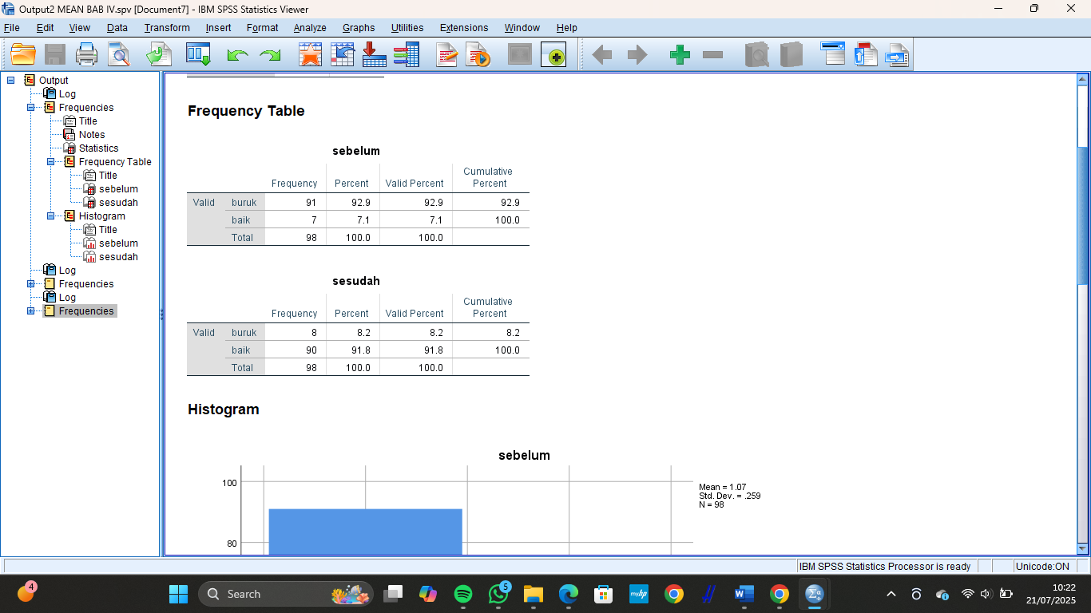
Distribusi Frekuensi Pengetahuan Santri sebelum diberikan promkes

Distribusi Frekuensi Pengetahuan Santri sesudah diberikan promkes

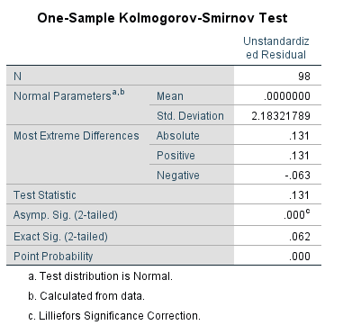
Uji Normalitas

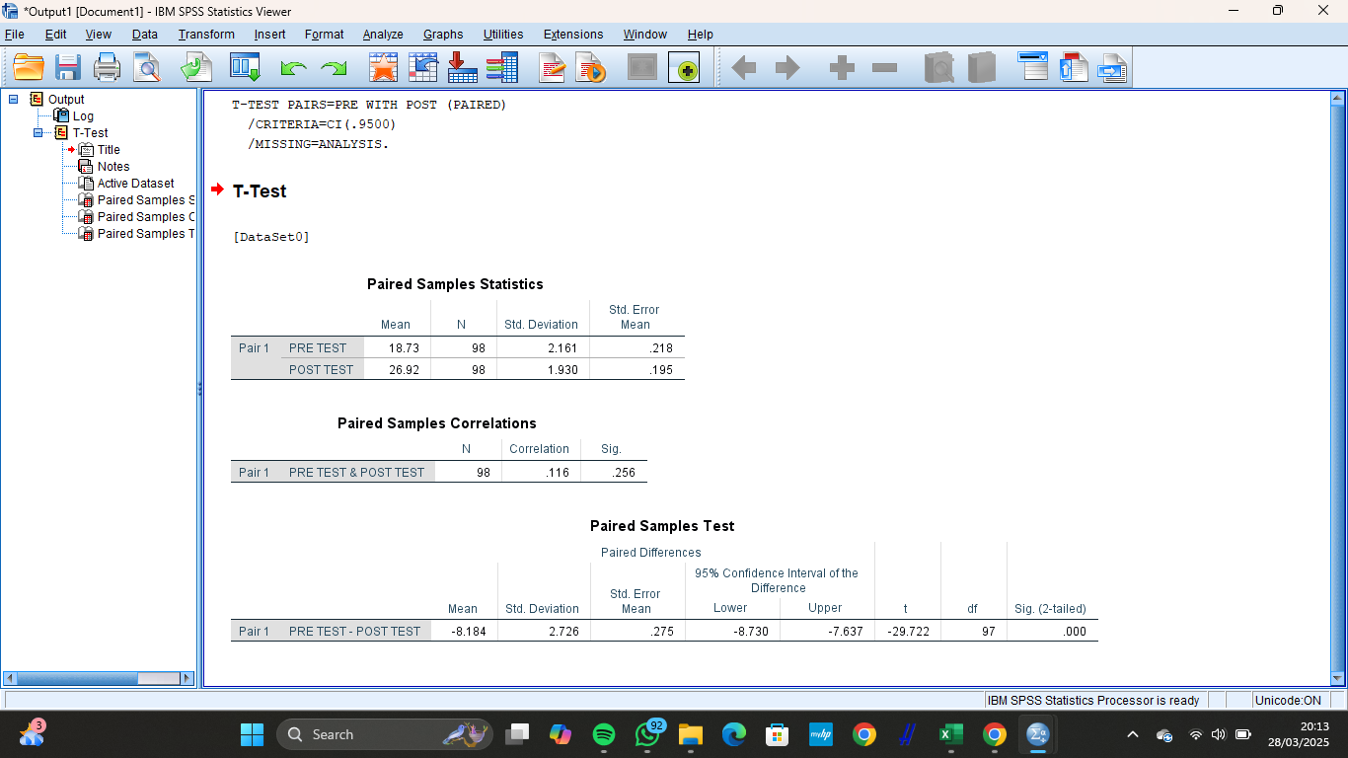
Rata-rata Nilai Pengetahuan Santri Sebelum dan Sesudah

Hasil Paired Sample t-test

Lampiran 7
DOKUMENTASI

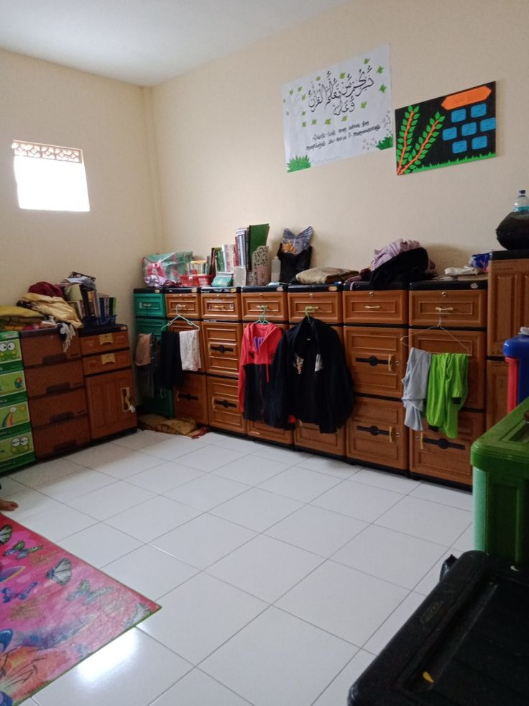 | 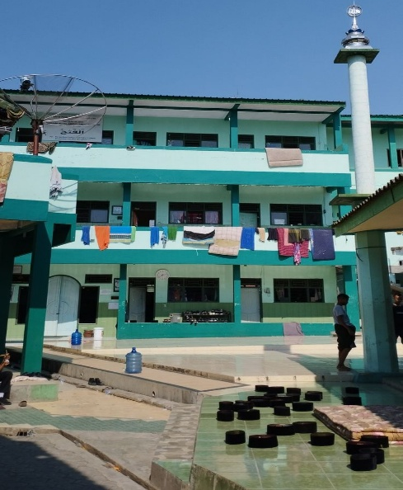
Gambar 1 kamar santri | Gambar 2 tempat santri mandi dan menjemur pakaian

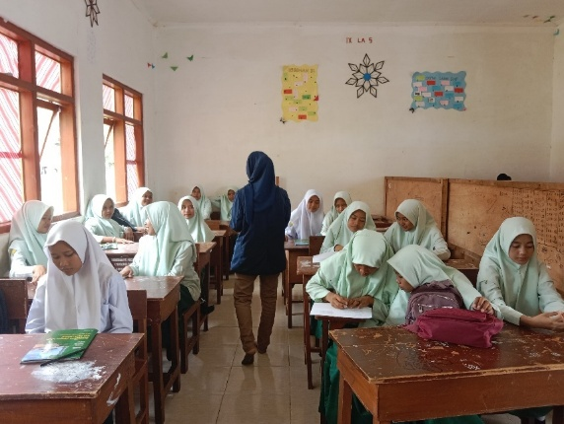 | 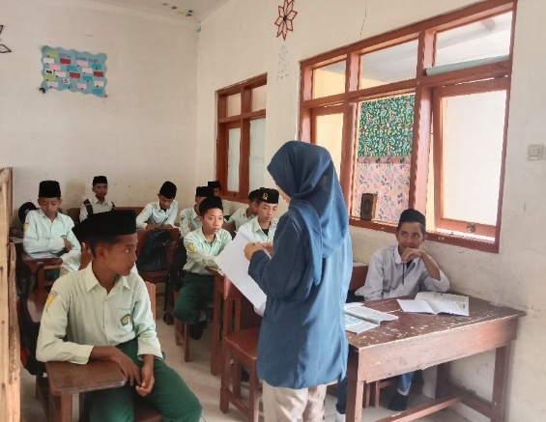
Gambar 3 Pemberian formulir pertanyaan | Gambar 4 Pemberian formulir pertanyaan

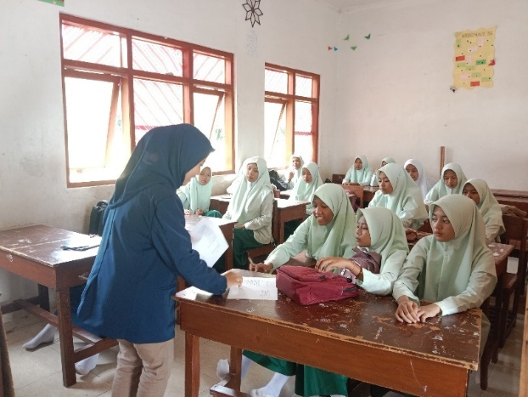 | 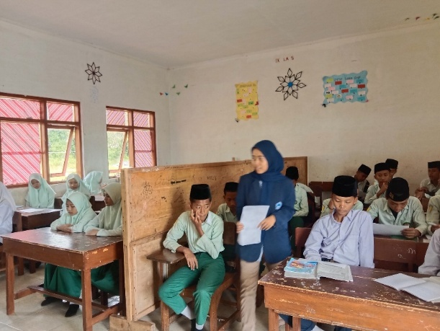
Gambar 5 Pengisian Formulir Pertanyaan | Gambar 6 Pengisian Formulir Pertanyaan

